7TH Annual WINTER GALA

LOT NO.
OFFICE USE
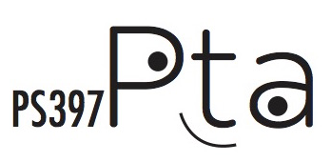

COMPANY NAME: COMPANY WEBSITE: ADDRESS:

TELEPHONE: EMAIL ADDRESS:
DONATION EXPIRATION DATE (if applicable):

DESCRIPTION OF HOW YOU WANT YOUR DONATION TO APPEAR IN THE CATALOG:

DONOR PRINTED NAME:
DONOR SIGNATURE:

VALUE OF DONATION $:
SOLICITED BY:

I would like to use THIS FORM as a donation certificate.
I will mail or drop off my item at The Spruce Street School PS397 PTA MAILBOX, 12 Spruce Street, NYC 10038.
I would like my item picked up. Date ready by:

I would like to underwrite a portion of the event / purchase an ad / be a sponsor. (circle one)

FOR MORE INFORMATION, PLEASE EMAIL: GALA@SPRUCESTREETNYC.ORG
The Spruce Street School PS 397 Parent-Teacher Association Inc. is recognized by the Internal Revenue Service as a 501(c)(3) tax-exempt organization.
Employer Identification Number: 27-0492999. All contributions are tax deductible to the extent permitted under the law.

